How to create Spring boot project?
Go to browser open website called https://start.spring.io/

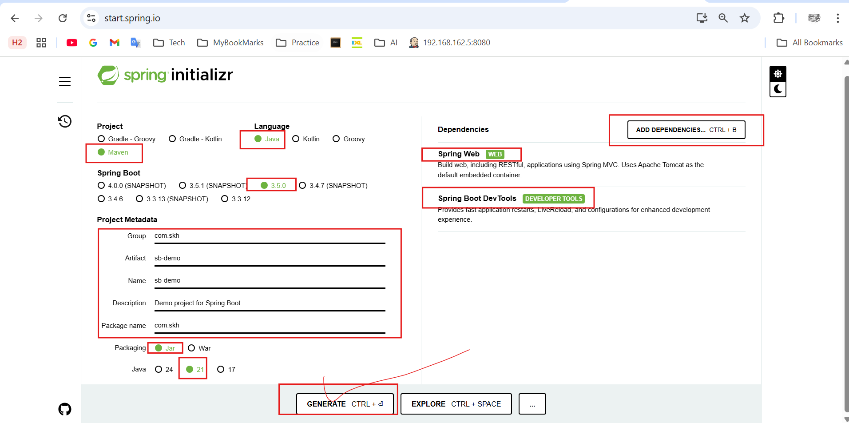
New latest one:
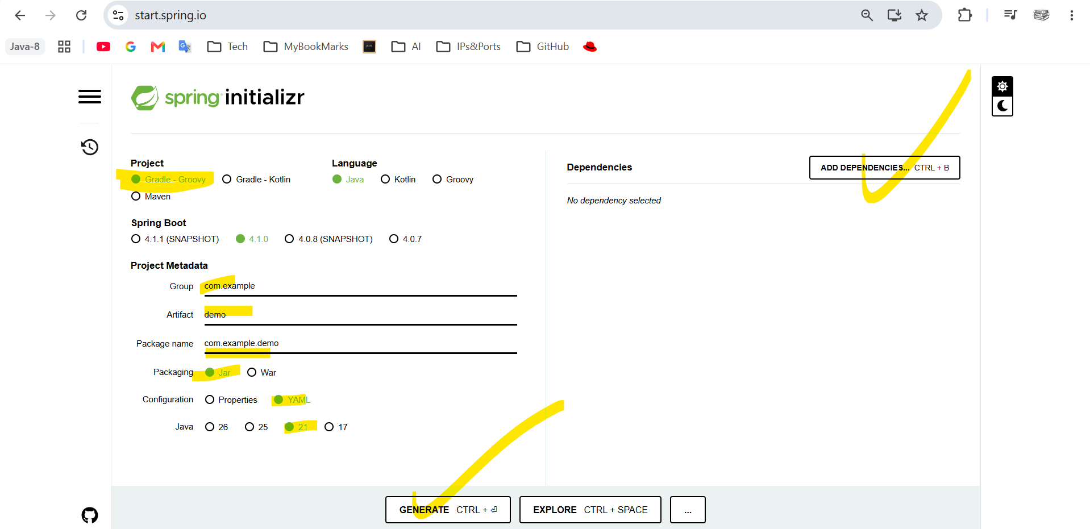

If you don’t know java version installed in your computer.
Open command prompt and run > java –version it will display java version in your system.

Finally click on “Generate” button.
It will download the .zip file into downloads folder.
Go to Downloads folder and extract the .zip file. You will get the project folder.

From above:
Spring web is for creating web application.
Spring Boot Dev Tools is for restarting the server automatically when any changes happened in code.

Question:
What is the difference between spring web dependency and spring reactive web (Web Flux) dependency?
Comparison Summary
Feature | Spring Web (MVC) | Spring Reactive Web (WebFlux)
Model | Blocking | Non-blocking
Server | Tomcat (commonly) | Netty (commonly)
Return Type | Object | Mono / Flux
Database | JPA, Hibernate, JDBC | R2DBC, Reactive MongoDB
Learning Curve | Easy | Steeper
Best For | CRUD, enterprise apps | High concurrency, streaming, API aggregation
Debugging | Easier | More complex
Thread Usage | One thread per request | Small event-loop thread pool

https://chatgpt.com/c/6a6ff145-3350-83ee-8e48-cf58cefbdad5

Now open STS / IntelliJ and import this new project there.

How to import new project into STS?
Open STS File Import maven Existing maven project Next Browser your project from downloads folder click on Finish button.

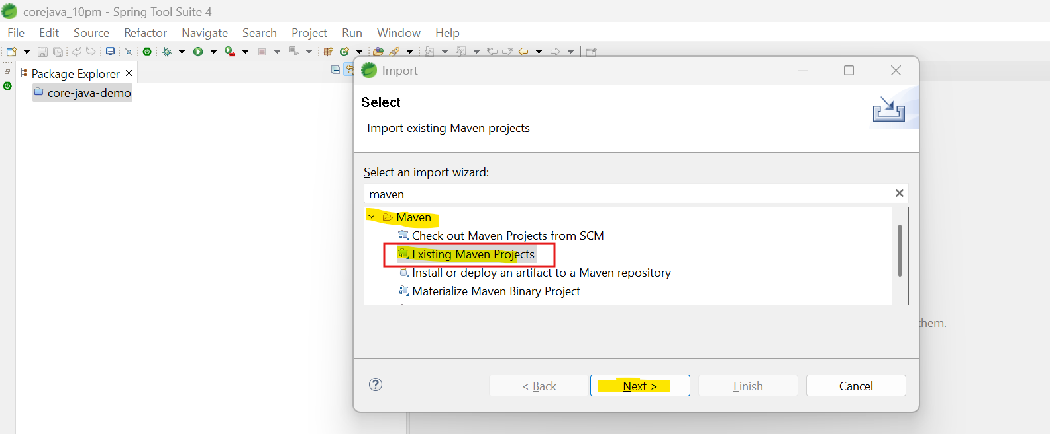
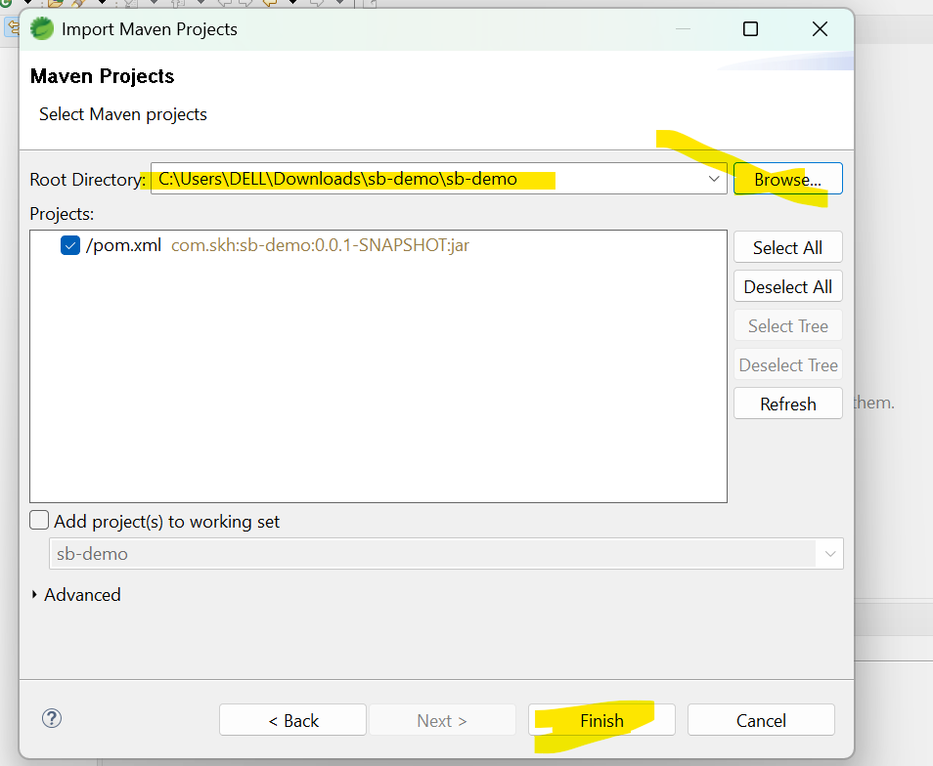

After clicking project wait for few minutes. It will be downloaded from server.
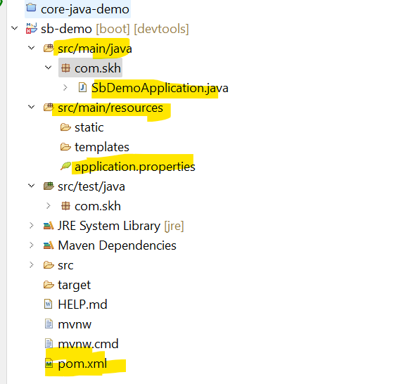

Project 1:
Changes required to do:
1.create a class and add @RestController annotation on class. Eg: DemoController.java.
2.change name of application.properties file name into application.yaml file.[right click -> refractor-> rename]
3.[OPTIONAL]In the application.yaml file add server port number, number can be anything you interested. Like.. 9000,
9001, 9002…….etc.
4.create methods in controller class you created, and add Request method type annotations….with path endpoint.
@GetMapping(path=”/endpoint”), @PostMapping(path=”/endpoint”), @PutMapping, @DeleteMapping..
5.start the server:
1st approach: right click on project Run As Spring boot App server will start, you can see on console.
2nd approach: Open main class right click on class run as java application.
6.Access the controller class method endpoint using IP address and port number and method end point.
http://localhost:9000/fetchName
here ->http/https is server PROTOCOL.
->localhost is IP Address of the server.
-> 9000 is port number of running server.
-> fetchName is controller method endpoint.

Go to Browser and use above URL.

DemoController.java application.yaml
package com.skh;  import org.springframework.web.bind.annotation.GetMapping;  import org.springframework.web.bind.annotation.RestController;  @RestController  public class DemoController {  @GetMapping(path = "/fetchName")  public void m1() {  System.out.println("Hi this is Kamal..!");  }  @GetMapping(path = "/fetchNumber")  public int m2() {  return 123;  }  @GetMapping(path = "/fetchFullName")  public String m3() {  return "Shaik Azad...! Welcome to Spring boot..!";  }  } | server:  port: 9001

In application.yaml/yml always maintain spaces properly.
If we don’t add port number in application.yaml file. Tomcat server by default takes 8080 as default port number.
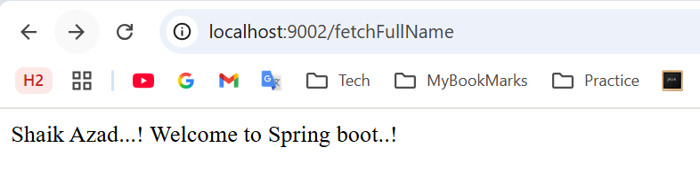
To see all the PORTs used in a system, we can use below command on CMD. Run below command on CMD.
C:\Users\Dell>netstat -ano

How many ways we can send the request to the server?
There are so many ways are there.
- Using browser form / Browser UR L– real time tools
- HTML form with html code.
- JavaScript file with JS code
- Postman – DEVELOPER tools for testing.
- JMeter – DEVELOPER tools for testing. (Performance testing/Integration testing)
- Hopscotch – DEVELOPER tools for testing.

etc……

How to send data from UI / browser to controller method?
- Using path variable: URL/inputValue
http://localhost:9002/fetchFullName/AZAD....

@GetMapping(path = "/fetchFullName/{fName}")
@PathVariable annotation in method parameter level.

@GetMapping(path = "/fetchFullName/{fName}")
public String m3(@PathVariable String fName) {
return String.format("Hi %s welcome to Spring boot", fName);
}

- Using query String. URL?key=value&key=value&key=valueY&key=value&….
http://localhost:9002/sendQueryParams?name=kamal&city=hyd&pin=534456
@RequestParam
Here : http – protocol
localhost – IP Address
9002 – PORT number.
sendQueryParams – Endpoint
?name=kamal&city=hyd&pin=534456 – Query String.

http://localhost:9002/sendQueryParams?name=Arafth&city=mvg&pin=343434
@GetMapping(path = "/sendQueryParams")
public String m4(@RequestParam String name, @RequestParam String city,
@RequestParam String pin) {
return String.format("My details %s - %s - %s ",name, city, pin);
}

- By submitting form.

@GetMapping(path = "/percentage/{tmarks}/{hMarks}/{emarks}")
public Integer calculatePercentage(
@PathVariable Integer tmarks,
@PathVariable Integer hMarks,
@PathVariable Integer emarks) {
Integer percentage = ((tmarks + hMarks + emarks) * 100) / 300;
return percentage;
}

We have seen problem with Path vriables. If we want o send more values we will send n path variables only but it will confuse us.
http://localhost:9001/percentage/67/75/88/56/ssdfsdf/454543/sfsdfsdf/2242343
In this above URL, we don’t know which values is what for?

To overcome this we can use of “Query String” approach.
Payload means? what ever the data we are sending to server is called as Payload.
http://localhost:9001/calculatePerWithQString?matchMarks=80&sceinceMarks=78&socialMarks=67
@GetMapping(path= "/calculatePerWithQString")
public String calculatePerWithQString(
@RequestParam Integer matchMarks,
@RequestParam Integer sceinceMarks,
@RequestParam Integer socialMarks) {
Integer percentage = ((matchMarks + sceinceMarks + socialMarks) * 100) / 300;
return "Your percentage is : "+percentage;
}

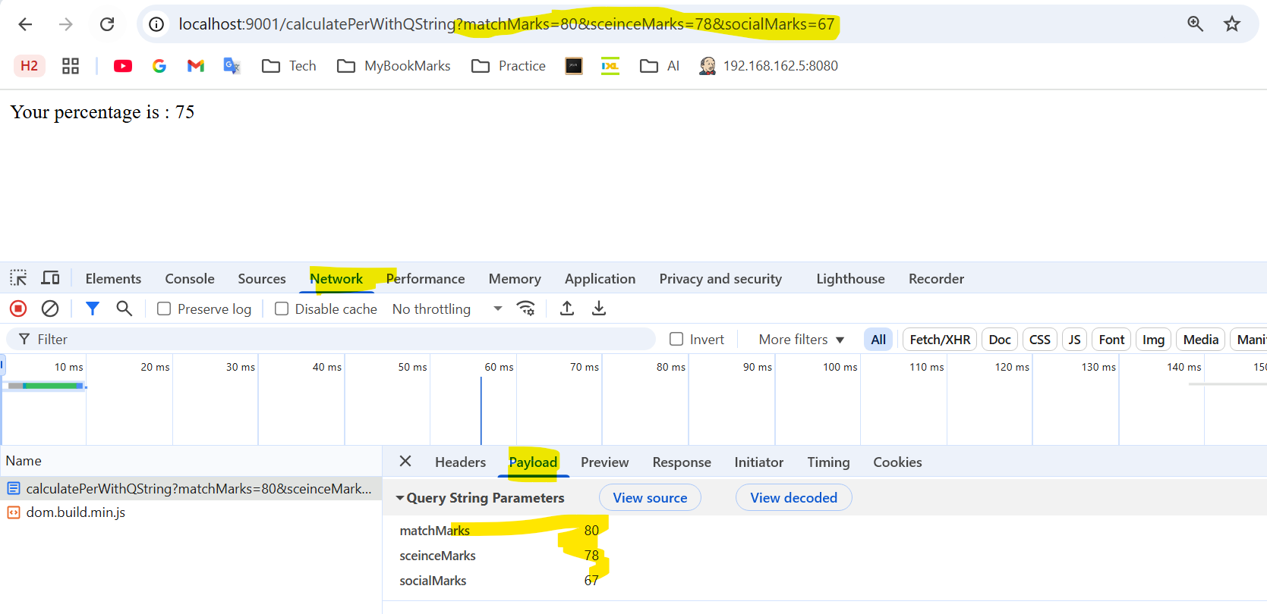

When we send request from browser [normal request, path variable request, query string request], by default browser always sends “GET” request only.
Particularly path variable and Query string approach always sends GET request only.

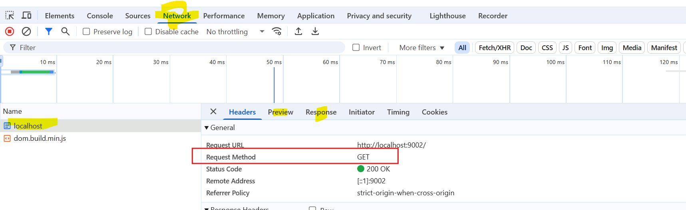

If we add @PostMapping in controller and if we send GET request from the browser, we will get below error on browser console.
@PostMapping("/")
public String defaultDisplay() {
return "Welcome to Spring boot...! This is Dahsboard / Homepage";

}

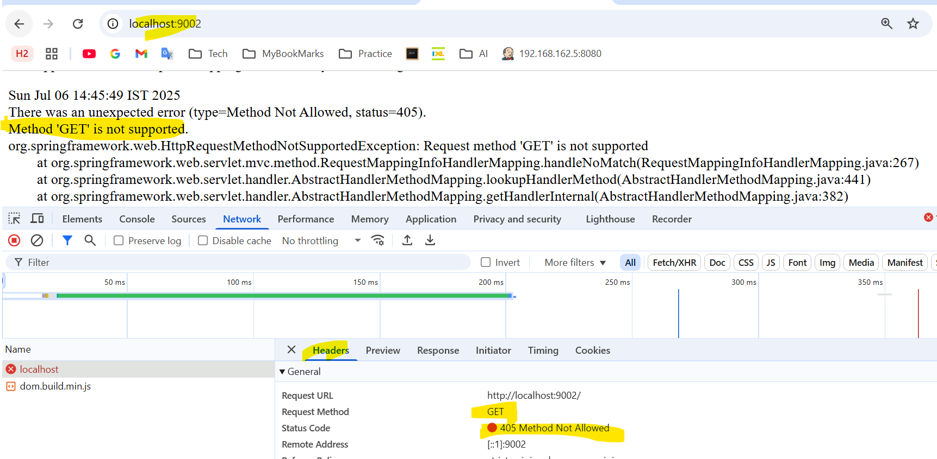

How to send the POST request in Web application [servlets / JSP / Spring / Spring boot / Angular/ ReactJS]?
- By using html <form method=”POST”> we can send POST request. [while using Angular and ReactJS]
- By using Java script code, we can send POST request. [while using Java script application]
- By using POSTMAN, we can send POST request. [while working with Spring boot]
- By using jMeter, we can send POST request. [while working with Spring boot]
- Etc……
By default, browser always send GET request only, but for sending POST, PUT, DELETE ..etc kind of requests we need to use above approaches.

Can we send path variables and query string in POST request?
Yes, we can send. How we sent for GET request similar way we will send in POST request also.
The only difference is we use @PostMapping annotation in controller method and we use POSTMAN or jMeter for sending POST request.

Controller code:
@PostMapping("/pRequest/{myName}")
public String defaultDisplay(@PathVariable String myName) {
return "Welcome to Spring boot...! This is Dahsboard / Homepage : " + myName;
}

@PostMapping("/pRequestWithQS")
public String pRequestWithQS(@RequestParam String myName, @RequestParam Integer myAge) {
return String.format("Hi..%s, your age is %d", myName, myAge);
}

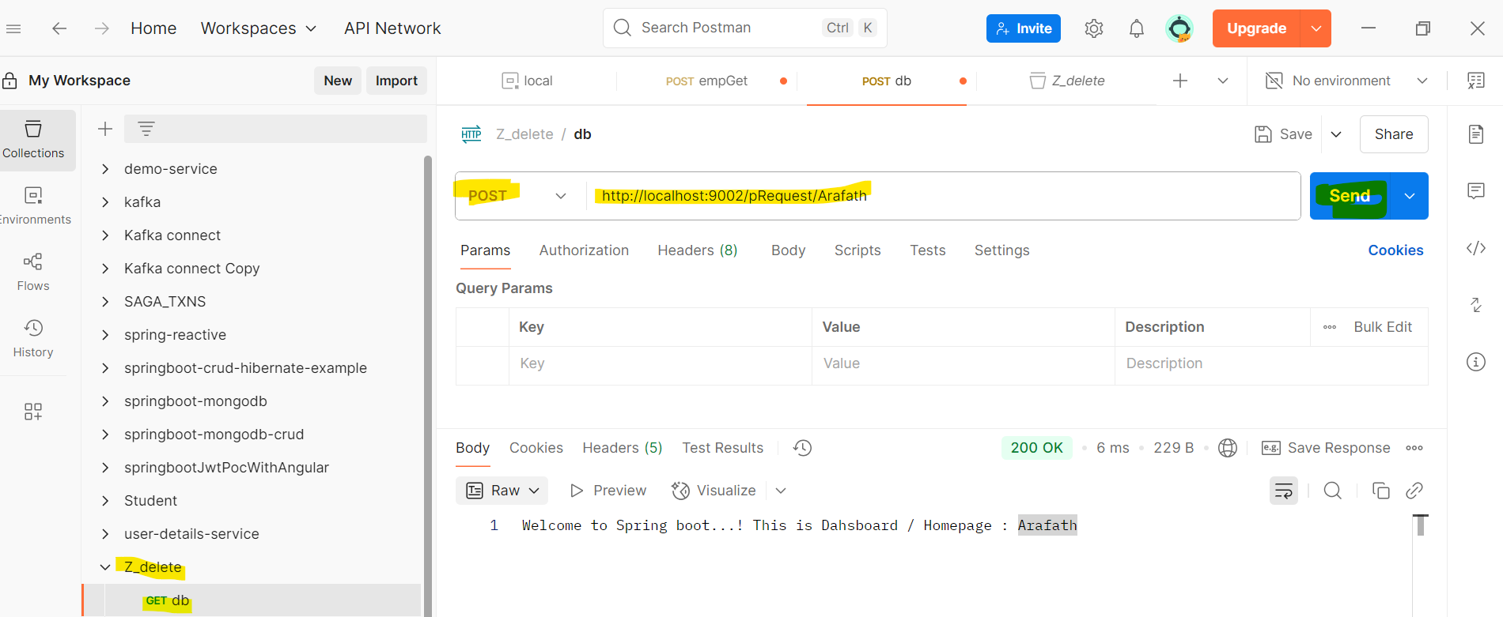

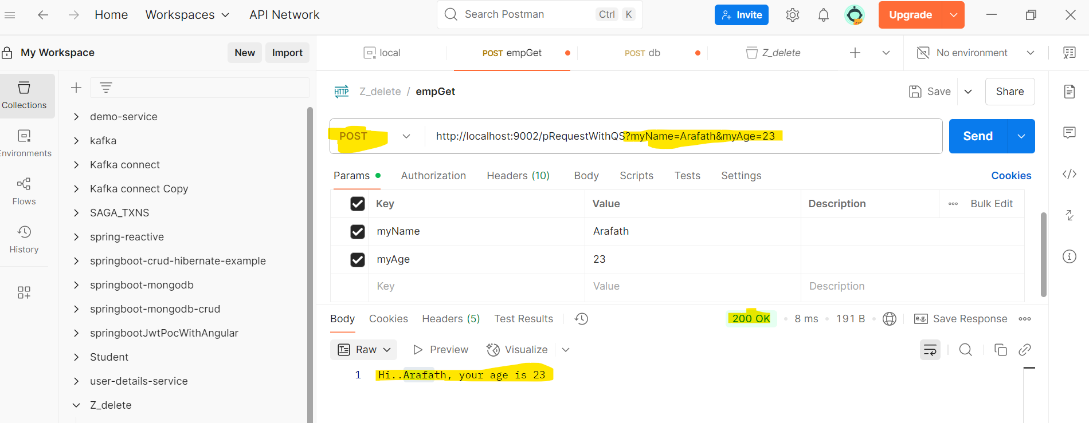

But, while working with POST method it is not recommended to send path variables or query string.
We have drawbacks with path variables and query string, when we send data using path variables or query string that data is visible in browser URL bar.

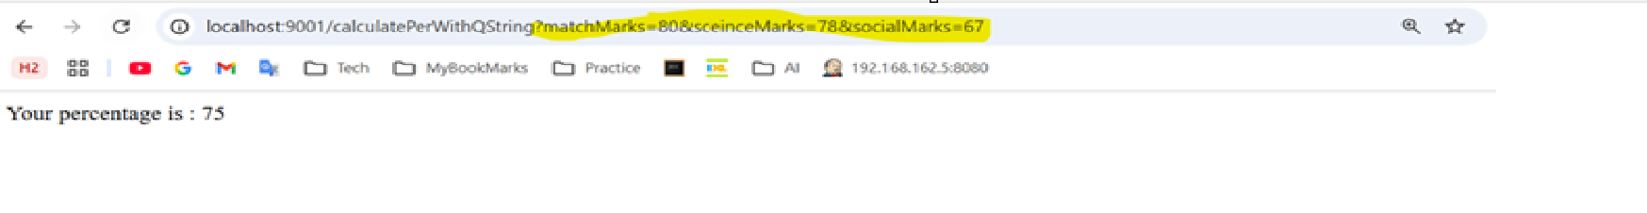

We should not use path variables or query string for sensitive [passwords, bank account numbers, PAN, Aadhar, OTP…] data.

To overcome the drawbacks of GET request, they introduced POST request type.

To send data to server in secured manner by using POST method, we need to use payload / request body approach.
When we are working with path variable we used @PathVariable annotation and we use @RequestParam annotation for query string approach.

Now for sending request payload in POST request, in the controller we use @RequestBody annotation.

Path variables @PathVariable
Query String @RequestParam
Request payload in POST @RequestBody

How to send request payload from POSTMAN?

@PostMapping(path = "/saveEmpData")
public String saveEmpData(@RequestBody String empName) {
return String.format("Hi...%s", empName);
}

From POSTMAN. Send POST request.

Steps:
- Select Body tab.
- Select raw radio button.
- Select TEST from below.
- Pass value like shown below.
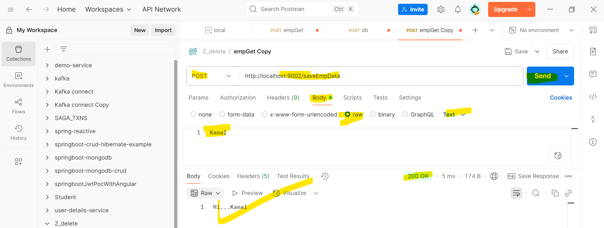

We can see above, what ever data we sent, it is not shown in URL bar, means we are sending data securely.
How to send multiple data in POST request?
Ans: We have to use POJO class.

What is POJO (Plain Old Java Object) class? How to create it? What is use of it?
It is a plain java class which have only private fields, default constructor, setter methods, getter methods and toString() method.

For storing data in POJO class instance variables we use setter method.
For getting / fetching data from POJO class instance variables we use getter methods.

Pojo class will be used for storing the data transferring the data from one place to another place.
While sending data as POJO class, we need to send as JSON object from POSTMAN.
JSON object means data always send in {} braces, in key:value format. Keys will be double quotes, values will be according to data type.
{
"empName" : "SAAASS",
"empId" : 123
}
For example:
public class EmployeePojo {
/*
* private fields default contructor setters & getters toString() method for
* testing.
*/
private String empName;
private Integer empId;

/*
* create setters and getters..
* right click on file --> source --> click on "Generate getters and setters.."
*
*/

@Override
public String toString() {
return "EmployeePojo [empName=" + empName + ", empId=" + empId + "]";
}
}
Binding?
Property name we sent and property name in pojo class matched then only biding happens and data will be given to pojo class property. If not matched it will take default values of pojo class property.

Controller code:
@PostMapping(path = "/saveEmpData2")
public String saveEmpData2(@RequestBody EmployeePojo empObj) {
return "Hi... : " + empObj;
}

Now send request from POSTMAN.

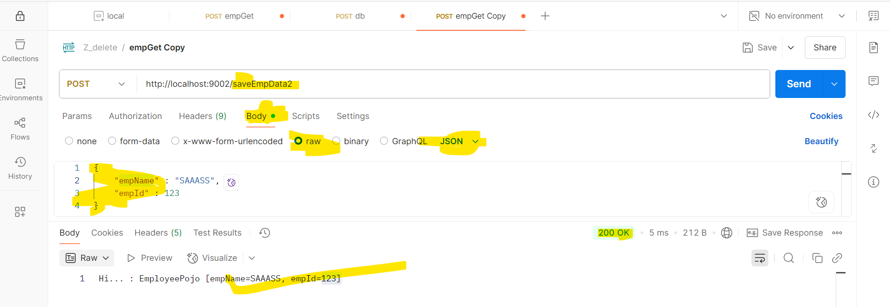
Another example:
@PostMapping(path = "/saveEmpData2")
public String saveEmpData2(@RequestBody EmployeePojo empObj) {
System.out.println(empObj); // store in DB
return "Hi..." + empObj.getEmpName() + " your data save in DB successfully!" ;
}

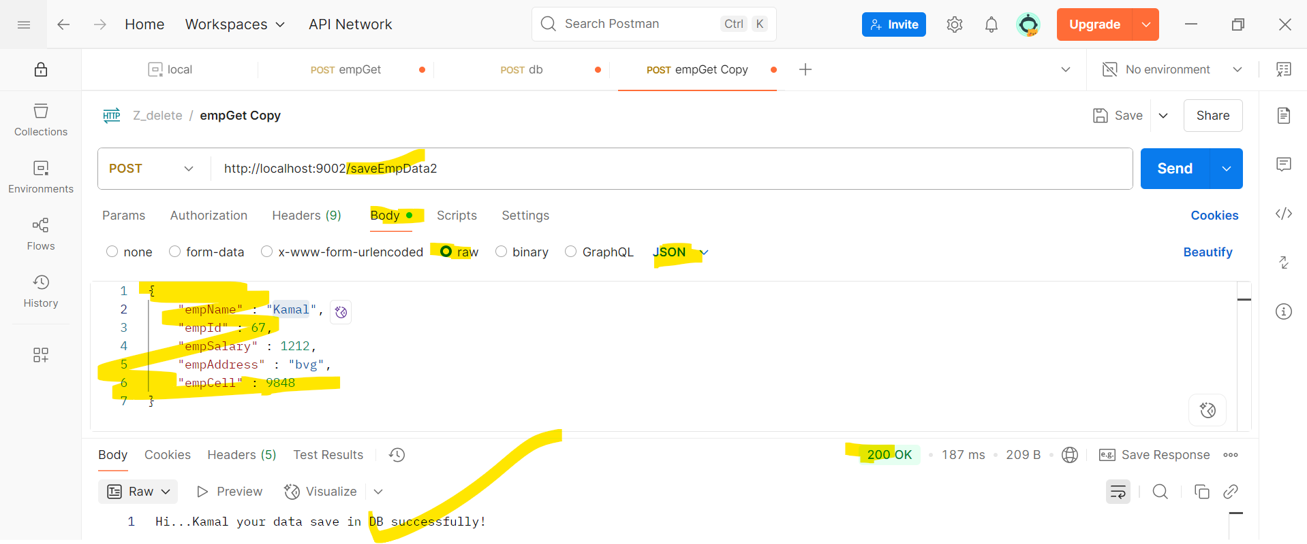
Based on your input data we need to create those many fields in POO class.
public class EmployeePojo {
private String empName;
private Integer empId;
private Double empSalary;
private String empAddress;
private Integer empCell;
// setters and getters
// toString() method.
}
Complete controller example:
@RestController
public class DemoController {

@PostMapping("/pRequest/{myName}")
public String defaultDisplay(@PathVariable String myName) {
return "Welcome to Spring boot...! This is Dahsboard / Homepage : " + myName;
}

@PostMapping("/pRequestWithQS")
public String pRequestWithQS(@RequestParam String myName, @RequestParam Integer myAge) {
return String.format("Hi..%s, your age is %d", myName, myAge);
}

@PostMapping(path = "/saveEmpData")
public String saveEmpData(@RequestBody String empName) {
return String.format("Hi...%s", empName);
}
@PostMapping(path = "/saveEmpData2")
public String saveEmpData2(@RequestBody EmployeePojo empObj) {
System.out.println(empObj); // store in DB
return "Hi..." + empObj.getEmpName() + " your data save in DB successfully!" ;
}
}

MVC flow:
Model business logic, DB callings logics service layer. java class @Service
View Response view layer. html, JS, Angular, react, Postman, jMeter, hopscotch.
Controller request/response processing logic layer java class @RestController.

View < Controller <- Service < Repository(DB).

What is the use of “@Autowired” annotation?
When we use @Component/@RestController/@Service/@Repository annotations on any class, spring IOC container creates object of that class and put that created object in Spring IOC container memory.

Now I want to get that object stored in Spring IOC container memory to any other class. That time we can use that @Autowired annotation with instance variable declaration.
@Autowired
private EmployeeService employeeService;

@Autowired
private EmployeeRepository employeeRepository;
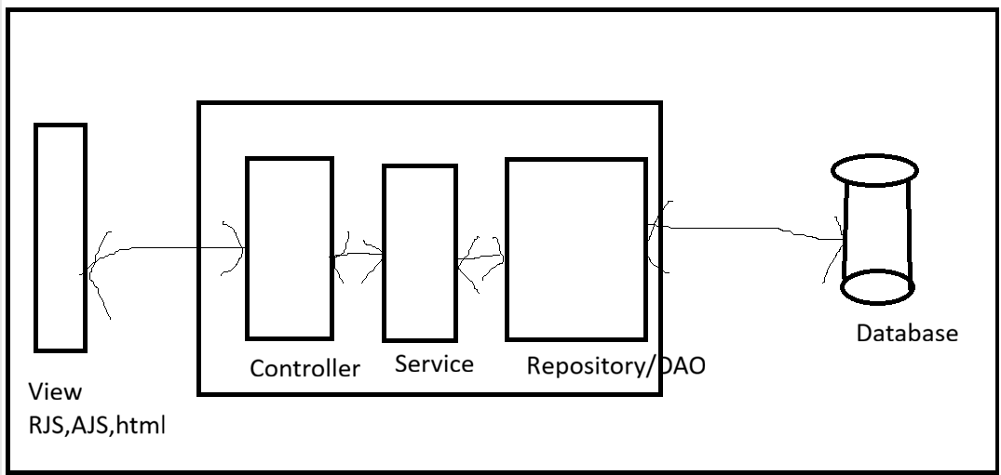

🧱 1. DDL (Data Definition Language)
DDL commands define, change, or destroy the structure of database objects like tables, views, and indexes. These commands change the database schema, not the actual records. [1, 2]
- CREATE: Makes a new table or database.
- ALTER: Modifies the structure of an existing table, like adding a column.
- DROP: Permanently deletes a table or database and all its records.
- TRUNCATE: Removes all records from a table but keeps the structure intact. [1]
🛋️ 2. DML (Data Manipulation Language)
DML commands manage the data inside the tables. They allow you to add, change, or remove rows of information. [1]
- INSERT: Adds new records to a table.
- UPDATE: Modifies existing data within a table.
- DELETE: Erases specific records based on a condition. [1, 2]
🔍 3. DQL (Data Query Language)
DQL is used exclusively for retrieving and looking at data. [1, 2]
- SELECT: Fetches data from one or more tables. (Note: Some documentation groups SELECT under DML). [1, 2]
🔑 4. DCL (Data Control Language)
DCL commands handle security, user access, and permissions for the database system. [1, 2]
- GRANT: Gives a user access permissions to the database.
- REVOKE: Takes away a user's access permissions. [1]
🔄 5. TCL (Transaction Control Language)
TCL commands manage the execution of DML operations to ensure data integrity. They group multiple actions into a single safe transaction. [1, 2, 3]
- COMMIT: Saves all changes made during the transaction permanently.
- ROLLBACK: Undoes changes if an error occurs, restoring the database to its last saved state.
- SAVEPOINT: Sets a temporary checkpoint within a transaction to roll back to if needed. [1]

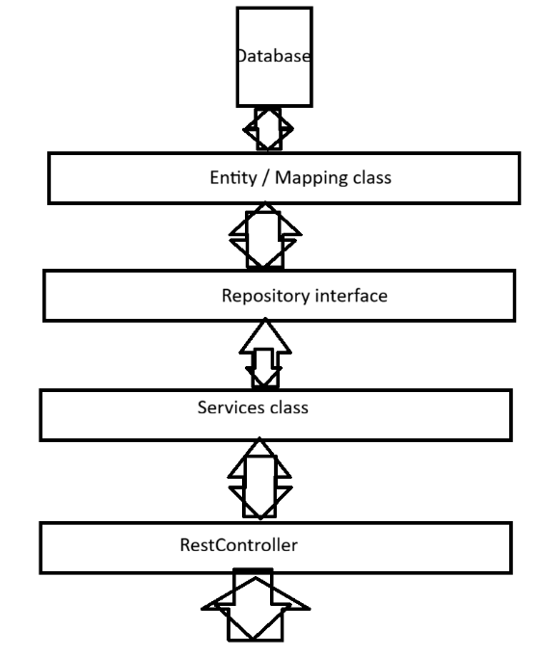

All database operations are done by repository reference only. Which are done in service class.
On DB we always can perform only 4 operations: CRUD / CURD
- Create -> insert/ save
- Read -> fetch/select/find
- Update -> update
- Delete -> delete/remove

Data types covered
Java Type | Example | Typical MySQL Type
String | firstName | VARCHAR
Integer | age | INT
int | experience | INT
Long | mobileNumber | BIGINT
Double | rating | DOUBLE
double | performanceScore | DOUBLE
Float | bonusPercentage | FLOAT
Boolean | active | BOOLEAN
boolean | verified | BOOLEAN
Short | leaveCount | SMALLINT
Byte | grade | TINYINT
BigDecimal | salary | DECIMAL
Character | gender | CHAR
Enum | employmentType | VARCHAR
LocalDate | dateOfBirth | DATE
LocalTime | joiningTime | TIME
LocalDateTime | createdAt | DATETIME
UUID | employeeUuid | BINARY(16) / CHAR
byte[] | profilePicture | BLOB

https://www.tutorialspoint.com/spring_boot/index.htm

@SpringBootApplication
@SpringBootConfiguration @Configuration
@EnableAutoConfiguration
@AutoConfigurationPackage @Import
@Import
@ComponentScan @Repeatable
The entry point of the Spring Boot Application is the class contains @SpringBootApplication annotation. This class should have the main method to run the Spring Boot application. @SpringBootApplication annotation includes Auto- Configuration, Component Scan, and Spring Boot Configuration.
If you added @SpringBootApplication annotation to the class, you do not need to add the @EnableAutoConfiguration, @ComponentScan and @SpringBootConfiguration annotation. The @SpringBootApplication annotation includes all other annotations.

Component Scan
Spring Boot application scans all the beans and package declarations when the application initializes. You need to add the @ComponentScan annotation for your class file to scan your components added in your project.

Auto Configuration
Spring Boot Auto Configuration automatically configures your Spring application based on the JAR dependencies you added in the project. For example,

Spring Boot - Quick Start using CLI
To run spring boot application from CLI command/gitbash, first build that project
$ gradlew clean build
This will generate .jar file in project /build folder. Now open gitbash there and run below command.
$ java -jar <jarFile_name>
$ java -jar sb-standalone-demo-0.0.1-SNAPSHOT.jar

Spring Boot - Tomcat Deployment:
JAR Java Archive File. [internally SB contains NETTY web server]
WAR Web Archive File. [we need to install external web server and deploy our project]
EAR Enterprise Archive File.

Tomcat Deployment:
- Download latest tomcat https://tomcat.apache.org/download-11.cgi
- Setting JAVA_HOME is must to start tomcat server.

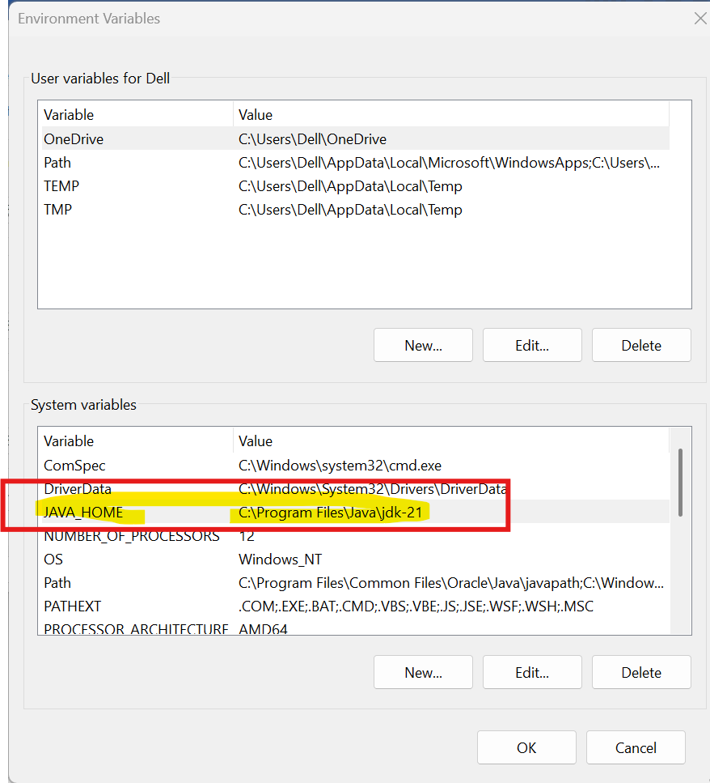

- Add user related user name and password in “tomcat-user.xml” file in below path.
[D:\softwares\apache-tomcat-11.0.10-windows-x64\apache-tomcat-11.0.10\conf]

tomcat-users.xml
<user username="admin" password="adminadmin"
roles="manager-gui,manager-script,manager-status,admin-gui"/>

- Starting Tomcat:
- Go to downloaded tomcat “bin” folder. apache-tomcat-11.0.10\bin
- Open CMD/Gitbash there and run > startup.bat
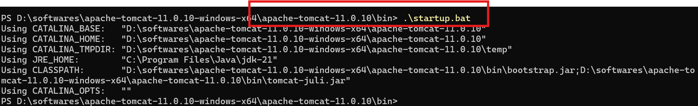

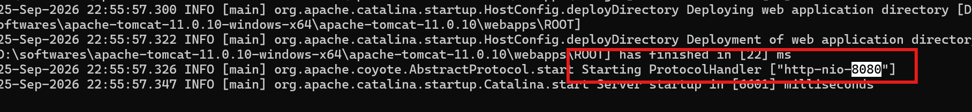
- Tomcat always starts on 8080 port number. To open browser and open http://localhost:8080

Browser opens like below.
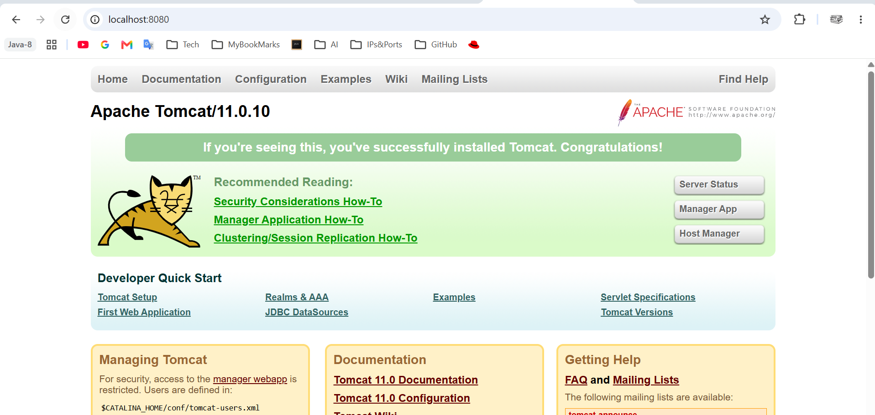

To deploy our .war file we need to click on “Manager App” button from above. It will ask for user name and password, please enter user name and password which you configured in tomcat-users.xml. For eg: admin/adminadmin.

Now from “WAR file to deploy” section please upload the war file which you created and click on deploy button, that’s all your web war application will be deployed in tomcat.
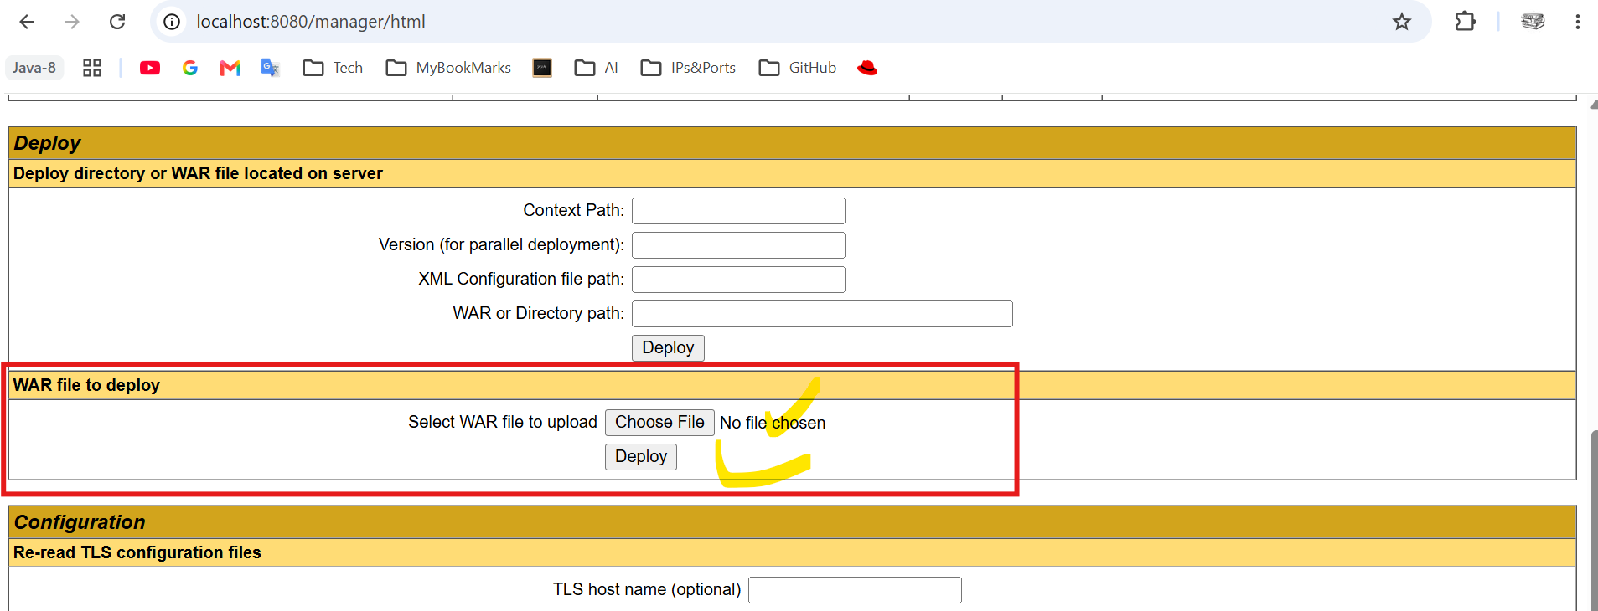
Now you can see tomcat deployed your war file location in tomcat webapps folder.
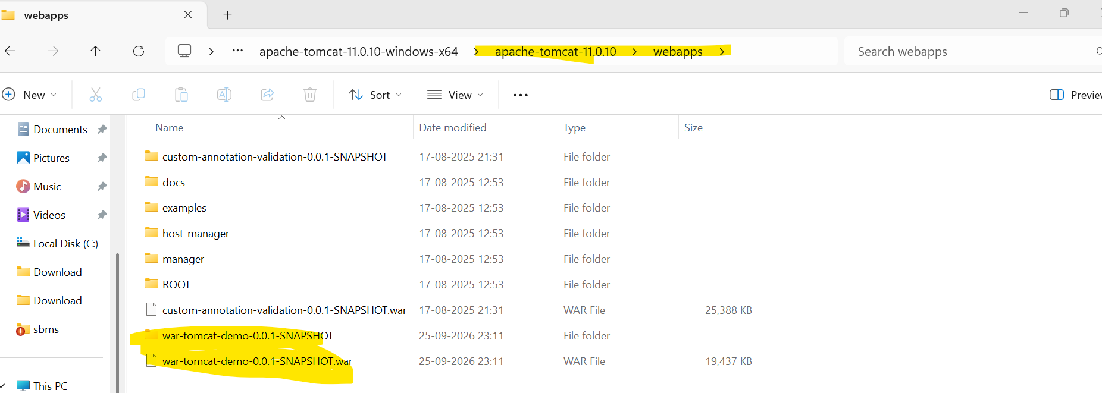

Sending GET request from JavaScript:
Test.html | UserCOntroller.java
<html>  <!DOCTYPE html>  <html lang="en">  <head>  <title>Employee Form</title>  <script src="test.js"></script>  </head>  <body>  <button onclick="callMyFunction();">Click</button>  <script>  function callMyFunction() {  fetch('http://localhost:9000/api/users/dummyUserData')  .then(res => res.text())  .then(result => console.log(result))  .catch(error => console.error('Error:', error));  }  let myFunction = (res) => res.text();  function f1(res) {  return res.text();  }  let f2 = (res) => {  return res.text();  }  let f3 = (res) => res.text();  let f4 = res => res.text();  </script>  </body>  </html> | package com.skh.controllers;  import com.skh.models.Employee;  import com.skh.models.UserData;  import jakarta.validation.Valid;  import org.springframework.http.ResponseEntity;  import org.springframework.web.bind.annotation.*;  import java.util.List;  @RestController  @RequestMapping("/api/users")  @CrossOrigin(origins = "*")  public class UserController {  @GetMapping(path = "/dummyUserData")  public ResponseEntity<UserData> fetchDummyUserData() {  UserData userData = new UserData();  userData.setUserId("A123");  userData.setSessionId("B123");  return ResponseEntity.ok(userData);  }  }

Submitting form from JavaScript:
Index.html TestController.java
<!DOCTYPE html>  <html>  <body>  <form>  Employee Name: <input type="text" id="empName" value="Kamal" /> <br>  Employee Id: <input type="text" value="12" /> <br>  Employee Sal: <input type="text" value="1234" /> <br>  Employee Address: <input type="text" value="BVG" /> <br>  Employee Cell: <input type="text" value="9848" /> <br>  </form>  <input type="submit" name="Submit" onclick="submitViaFetch()" /> <br>  <script>  function submitViaFetch() {  const employee = {  empName: document.getElementById("empName").value,  empId: 4554,  empSalary: 4545,  empAddress: "MVG",  empCell: 454  }  fetch('http://localhost:9002/saveFullEmpDetailsFromJS', {  method: 'POST',  headers: {  'Content-Type': 'application/json'  },  body: JSON.stringify(employee)  })  .then(response => response.text())  .then(result => console.log(result))  .catch(error => console.error('Error:', error));  }  </script>  </body>  </html> | @PostMapping(path = "/saveFullEmpDetailsFromJS")  public String saveFullEmpDetailsFromJS(@RequestBody Map<String, String> empObj) {  System.out.println(empObj); // store in DB  return "Hi..." + empObj.get("empName") + " your data saved in DB successfully!" ;  }

